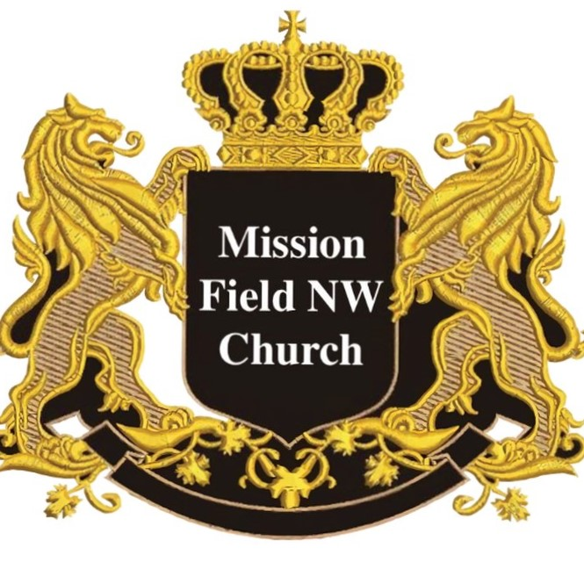

MISSION FIELD NW CHURCH
Est.2017
Established By Bishop/ Apostle Jermaine A. Williams Sr.
Milwaukee, Oregon MARCH 10TH, 2017
Grace and peace be multiplied to you in God our Father and in the Lord Jesus Christ.
I Bishop Jermaine A. Williams Apostle of the Lord Jesus by the will of God and under the anointing of the Holy Spirit, I'm writing this decree to lay foundation about:
MISSION FIELD NW CHURCH
This decree is to set in motion what the Church is to look like As you read below I will describe how it’s to operate. I will also describe who the leadership teams will be. And most importantly what we are to believe as a network of leaders. So to begin:

CHURCH DOCTRINE:
According to John 1:1-9
We believe that Jesus Christ is the Son of God, the word that became flesh to dwell among us. We believe he was born of the virgin to fulfill all the prophecies that God had ordained. We believe he is fully God and fully man Human enough to feel our pain and God enough to redeem us from sin.
According to 1 Timothy 2:5
By this we believe that there is no other mediator that we have in heaven except the man Christ Jesus.
According to Romans 3:12-31
We believe that we are justified by the death and resurrection of the Lord Jesus, which gives us eternal life and that the working of the Holy Spirit in our life is by Grace alone through faith alone. And the righteousness that we stand in as Sons and daughters of God is due to the sacrifice that Jesus made on the cross.
According to the book of Acts 1-3
We believe in the working of the Holy Spirit and the preaching of the Gospel for the salvation of all men no matter their ethnicity or racial background. We believe in birthing disciples that will follow the teaching of the Lord Jesus. We believe in signs and wonders and the miraculous working power of the Holy Spirit in and through the Church of God.

CHARACTER OF THE CHURCH:

MORALITY:
As Ministers of the Gospel the responsibility is to uphold the code of morality. Which is choosing to do what is right in the eyes of God. So when it comes to the issues of society we take the high road. So we desire to see love and restoration prevail in All Nations.

- We affirm that marriage is between 1 biological male and 1 biological female according to the will of God for long life, liberty & procreation
- We champion the cause of those who face injustice and slavery in all of its faces.
- We affirm the rights of all people to pray and read the word of God in public and in the privacy of their own homes
- We champion the cause of parents to raise their children as God intended with both parents serving the Lord and setting a Godly example for their offspring

ETHICS:
As Ministers of the Gospel the responsibility is to guide the people of God in a way that brings transformation and uplifts all Churches. The core is to push the body of Christ towards maturity in measures that help their communities and Nations prosper and be effective. So we do not believe in slavery at any level or hatred against another individual based on their culture or ethnicity. We condemn racism in all of its forms within society.
We promote social justice and equality.
We uphold the sanctity of life that begins in the womb. We disapprove and we reject the killing of the innocent and the unborn. We condemn all acts of violence and murderous ambitions and we call All Nations to a place of repentance unto salvation. Salvation within their own borders and Salvation to other nations that surround them

ORDER OF LEADERSHIP:
As the Presiding Bishop of the Lord's Church and Founding Apostle of this great Network of leaders and Pastors All instruction will come through the Word of God, Through Leading Officers and Through Me. This is what we call chain of command and leadership accountability
Officers of Organization are these:
- Apostolic Overseers
- Barry & Melissa Reber

- Elders & Apostolic Overseers
- Jim & Linda Moore

- Prophet Joe Wilkins

- Presiding Bishop & Founding Apostle & Prophet
- Jermaine A. Williams Sr.

ROLL CALL:
TO All other pastors and leaders that will be chosen and appointed among you and among your Nations and tribes as the church grows the understanding will be this, the names above are the people that you are held accountable to.
And if something is wrong within the church community that you are responsible for I as the Founding Apostle must know about it or one of the other officers namely the Overseers must know about it because the Lord has placed us as the shepherds over your lives to guard you and to protect you against wolves in sheep's clothing.
CHURCH OPERATION:
THE FLOW AND FUNCTION OF EACH CHURCH SHALL BE THIS AND IT CANNOT BE AMENDED OR CHANGED.
- We will have biblical teaching on Fridays & Sundays, times and dates will be determined and communicated. The Presiding Bishop will teach LIVE every weekend and there will also be videos that are recorded and transmitted so that the teaching is available to international pastors.
- We will have Outreach and evangelism in sharing the gospel to those who do not know it. And there will be baptisms for those who are dedicating or rededicating their life to the Lord Jesus.
- We will have leadership training for those that desire to serve in full time ministry. That is going to be our Revival School of Ministry and it is a requirement that all ministers go through the school at any level so that you continue to sharpen your understanding of the Word of God.
TITHE & OFFERINGS:
In regards to tithes and offerings the Overseer and Pastor of the church should take it up. He or She is permitted to go to each region where the church is represented to collect and distribute the tithe and offerings properly:
He or She would do this in three portions
1. The first portion goes to the upkeep of the church and those regions of its influence, expanding the church more (Bibles, chairs, Worship instruments etc.)
2. The second portion goes to the poor & Widows and those who have need of clothing and other necessities.
3. The last portion will be to The Pastors & their families & The Ambassador and to their family for their service to the community.

APOSTOLIC DIPLOMACY
INTERNATIONAL MISSIONS & GOVERNMENT PLATFORM

We are focused on meeting with national and local leaders. To discuss the issues that are concerning their Nations and Regions. We will discuss the areas of Social Justice Reform and Economic Equality. As well as topics on Education and Community Outreach to the poor and low-income workers
As the church we can be involved in all of these areas.

Our position and main goal is to maintain a voice of change and transformation in pushing towards what is Healthy & Economically Reliable for ALL of Humanities Children:
- By Communication with Leaders
- By Serving all people
- By Calling out corruption
- By Establishing safe havens for people to heal

PROPHETIC WORSHIP

& INTERCESSION
National Prayer Walks

Our focus is to bring the Light of the presence of God into the darkest places of the earth. To bring healing and transformation Through the Prophetic:

- Regional Prayer Watches/ Prayer Houses
- Prayer Chains over Governments
- Prayer Meetings with City Leaders
- Prayer Groups on Campus

EVANGELISM OVER REGIONS
Teaching & Preaching the Gospel
Raising up Disciples

Matthew 28:19-20
19 Therefore go and make disciples of all nations, baptizing them in the name of the Father and of the Son and of the Holy Spirit, 20 and teaching them to obey everything I have commanded you. And surely I am with you always, to the very end of the age.” - Jesus
​
This is our mandate from Jesus himself to cover the earth with the glorious gospel of the Kingdom.
This is the Gospel:
- The Preaching of Repentance from sin unto Salvation through the Redemptive Work of Jesus Christ By his death and resurrection.
- To accept the Grace & Forgiveness of God over your heart and life by faith in Jesus.
- To walk out a Righteous life by Grace until Christ returns.
- To Love as Christ loved you

